March Madness Fan Sentiment Analysis
Using YouTube Comments and the Cardiff NLP Twitter-RoBERTa Model to Evaluate Fan Emotion Across the 2026 Tournament
EECS 767 — Final Project Report
Newberry, Kyle – Renner, Ben
University of Kansas | Spring 2026

Abstract
This project investigated the relationship between a March Madness team’s seed and performance with sentiment expressed by fans in YouTube comments during the 2026 March Madness Tournament. We developed a pipeline, utilizing the YouTube Data API v3, to collect comments from 63 game highlight videos. This data was then passed through a RoBERTa model pre-trained on Twitter text and a customized JSON dictionary to assign sentiment to the teams being discussed in each comment. Through the analysis, the data concluded that average sentiment across the entire tournament was predominantly positive, being led by the 9 and 13 seeds. Conversely, negative comments were largely directed at the losing team for any given game, with the 8 seed being the most adversely affected by the 4 upsets in the round of 64. As the tournament progressed, the videos received more total comments, but mostly more positive comments. These results show an expected trend of fans engaging more positively as the tournament progresses and the matchups get more competitive.

1. Introduction
March Madness is the biggest event in College Basketball, including 64 teams competing across 63 single-elimination games. After each game, highlight videos are posted on YouTube, drawing fans into the comments to share their opinions on how the teams played. Evaluating these comments provides a good idea of what the average opinion is for a given team and their performance in the tournament.
Manually reading through thousands of comments is not feasible, so we built an automated pipeline to do so. Using the YouTube Data API v3, all of this data is freely and easily accessible, allowing for the feasible tracking of fan comments across the duration of the tournament. Feeding these comments into the cardiffnlp/twitter-RoBERTa-base-sentiment model extracts the sentiment behind each comment and assigns that to a team through a JSON dictionary, matching the contents of the comment to team names, coach names, and player names. The RoBERTa model was selected because of its training on tweets, with the hope that it would be able to properly assess emoji and slang usage present in the dataset. Lastly, the results are compiled, and trends are visible in the dataset across the tournament.

2. Data Collection
To assess sentiment towards each team, comments were gathered from YouTube using a custom Python script interfacing with the YouTube Data API v3. Each video was identified by its YouTube video ID, and a list of game labels (e.g., “UCONN-Duke”) was maintained to organize output files by matchup name.

2.1 API Requests and Pagination
To retrieve the comments, we used the commentThreads endpoint of the API v3, querying with the following parameters: part=snippit, maxResults=100, and order=relevance. This allowed us to return 100 comments ranked by their engagement level (most-liked first). However, because the API returns only a maximum of 100 comments per request, we implemented a pagination loop to collect all the comments on a video. Our pagination loop worked by checking the presence of a nextPageToken field after each response. If a nextPageToken was found, we would make another request with that token to retrieve the next page of results. This process continued iteratively until all the comments had been retrieved.
For each comment, four fields were extracted from the API response: the author’s display name, the full comment, the number of likes on the comment, and the publication date. These fields were stored as dictionaries and accumulated into a list for each video.

2.2 Data Storage and Output Format
Once all of the comments had been grabbed from each video, the data was written to an Excel workbook using the openpyxl library. Each workbook was organized into two sheets. The first sheet, labeled “Comments,” contained a formatted table with a lead header row and all of the grabbed comments (Figure 1). Each row contained all of the information from each comment along with a sequential index. For readability, column widths were adjusted, and the header row was frozen to remain visible during scrolling.
Figure 1 - Format from Alabama-Hofstra_comments.xlsx Comments Sheet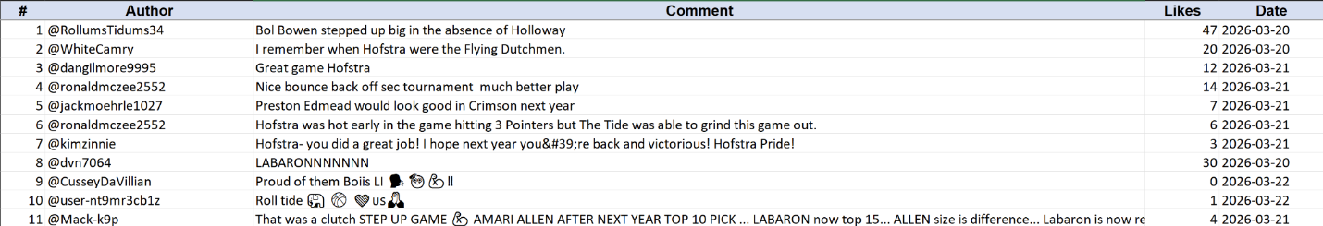
The second sheet, labeled “Info,” served as a metadata record for each file. This is where the video ID, YouTube URL, total comment count, and the date it was exported were stored (Figure 2).
Figure 2 - Format from Alabama-Hofstra_comments.xlsx Info Sheet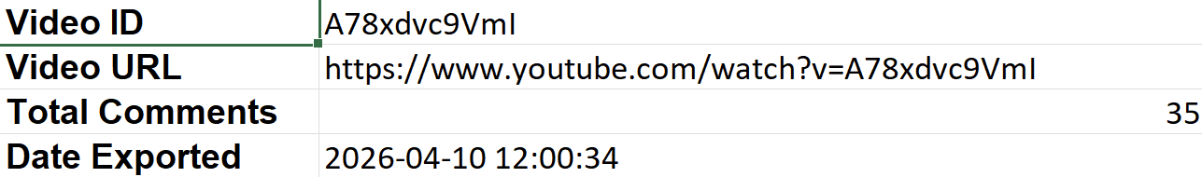

Output files were saved using the game label as the filename (e.g., UCONN-Duke_comments.xlsx). Because the March Madness Channel consistently places the winning team’s name first in video titles, this same ordering convention was maintained for sentiment analysis. In total, 5,116 comments were collected from the 63 YouTube videos.

3. Sentiment Analysis
Following data collection, we performed sentiment analysis using the Cardiff NLP Twitter-RoBERTa model to classify each YouTube comment by its associated team and emotional tone. Our program would read the input Excel files produced by the first script, run each comment through the sentiment model, tag which team each comment is about, and output two structured Excel files with the results.

3.1 Team Alias Configuration
To implement team attribution, we developed a JSON configuration file (MarchMadnessAliases.json). This file contained structured metadata for each team containing the following fields: file_names, aliases, coach, players, and ignored_words. The file_name field contained the front end of each file that referenced that team. The aliases field contained all the known aliases/acronyms that are commonly used to reference that team. The coach and players fields contained a list of names of key players and coaches broken down into full, first, and last names. While we planned to use the ignored_words when sorting, we ended up discarding this field, as the rest of the fields were all needed to give us good results. All keyword fields were normalized to lowercase at load time. With this JSON file, we were able to identify many comments associated with the given teams.

3.2 Team Detection
For each game file, the two competing teams were identified by parsing the filename and cross-referencing it against the file_names field in the alias configuration. The first team matched was treated as the winning team and the second as the losing team.
Each comment was then assigned to one of four categories: Team 1, Team 2, Both Teams, or Neither. Classification worked by searching the lowercased comment text for whole-word matches against each team's aliases, coach name, and player names, using boundary-aware regular expressions to avoid partial-word false positives. Comments matching keywords from both teams were labeled "Both Teams," while those with no team-specific matches were labeled "Neither." All other comments were attributed to whichever team's keywords were found.

3.3 Sentiment Classification Model
Sentiment classification was performed using the Cardiff NLP Twitter-RoBERTa model, a RoBERTa-base transformer that was fine-tuned on approximately 124 million tweets and subsequently fine-tuned for three-class sentiment classification (Positive, Neutral, Negative). The reason we selected this model was due to its strong performance on informal, short-form social media text. While it was made for Twitter (X), it translated well into analyzing YouTube comments.

Prior to inference, each comment was preprocessed to replace @-mentions with the token @user and URLs with http. The preprocessed text was then tokenized and passed through the model with a maximum sequence length of 512 tokens. Softmax was applied to the raw logits to obtain a probability distribution across the three sentiment classes. The class with the highest probability was assigned as the predicted label. To see how certain the model was on its classifications, the individual scores for all three classes were retained alongside the predicted label.

3.4 Output Files
In the end, our program produced two Excel files. The first file, all_comments_labeled.xlsx, contained every comment across all 63 game files in a single sheet. Each row contained the game name, team labels, team attribution tag, predicted sentiment, and all three sentiment confidence scores. Rows were color-coded by team attribution (blue for Team 1 (winners), orange for Team 2 (losers), green for both teams, grey for neither), and the sentiment cell was independently highlighted in green, yellow, or red for positive, neutral, and negative predictions, respectively.
The second file, sentiment_summary.xlsx, contained data summaries organized across five sheets: a full breakdown by game and team tag, and four per-bucket sheets (Team 1, Team 2, Both Teams, Neither). Each sheet presented comment counts and percentage distributions across sentiment classes for every game. These summary tables served as the primary dataset for statistical comparison of fan sentiment across matchups.

4. Results
In total, we retrieved 5116 comments. Of those, 2034 (40%) were labeled by the RoBERTa algorithm as positive, 1607 (31%) labeled neutral, and 1475 (29%) labeled negative. On top of the algorithm, we were able to attribute 1534 comments to the winning teams, 849 to the losing teams, 444 to both teams, and 2289 to neither team.

4.1 The Final Three Games

UConn vs. Illinois (Semifinal)
In the first game, we retrieved 163 total comments, of which 56 were labeled as positive, 65 negative, and 42 neutral. In terms of team affiliations, 65 comments were attributed to UConn, 22 to Illinois, 14 to both, and 62 to neither. In Figure 3, you can see sentiment distributions in terms of percentages. For this game, the winning team, UConn, received the highest percentage of positive comments with 40%, while the losing team, Illinois, received the highest percentage of neutral comments with 50%. Comments associated with both teams received the highest percentage of negative comments at 50%.
Figure 3 - Sentiment Distribution by Team Affiliation [UConn vs Illinois]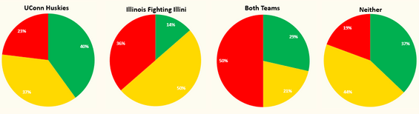
When totaling the sentiment for each team, Figure 4, any comments marked as “Both Teams” were added to the total for each individual positive, neutral, and negative counter. The reason behind this is that we don’t care about seed numbers at this point. After including these comments, we found that UConn received the most positive comments percentagewise, whereas Illinois received the most neutral and negative comments percentagewise.
Figure 4 - Sentiment Including “Both Teams” Comments [UConn vs Illinois]
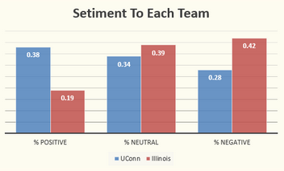

Michigan vs. Arizona (Semifinal)
In the second game between Michigan and Arizona, we retrieved 301 total comments, of which 119 were attributed as positive, 100 negative, and 82 neutral. In terms of team affiliations, 119 comments were attributed to Michigan, 38 to Arizona, 31 to both, and 113 to neither. In Figure 5, you can see sentiment distributions in terms of percentages. For this game, the winning team, Michigan, received the highest percentage of positive comments at 51%, while the losing team, Arizona, received the highest percentage of negative comments at 64%. Comments associated with neither team received the highest percentage of neutral comments at 33%.
Figure 5 - Sentiment Distribution by Team Affiliation [Michigan vs Arizona]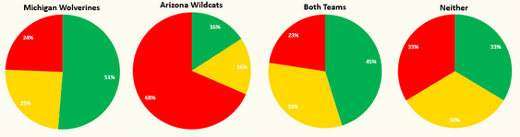
When comparing the sentiments to each team, Figure 6, we found that Michigan received the most positive and neutral comments percentagewise, whereas Arizona received the most negative comments percentagewise.
Figure 6 - Sentiment Including “Both Teams” Comments [Michigan vs Arizona]
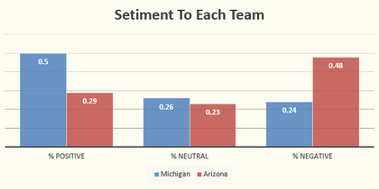

Michigan vs. UConn (Championship)
The final for March Madness was between the Michigan Wolverines and the UConn Huskies. For this game, we retrieved 391 total comments, of which 208 were attributed as positive, 96 negative, and 87 neutral. In terms of team affiliations, 139 comments were attributed to Michigan, 44 to UConn, 39 to both, and 169 to neither. In Figure 7, you can see sentiment distributions in terms of percentages. For this game, the winning team, Michigan, received the highest percentage of positive comments with 70%, while the losing team, UConn, received the highest percentage of negative comments with 48%. Comments associated with neither team received the highest percentage of neutral comments at 26%.
Figure 7 - Sentiment Distribution by Team Affiliation [Michigan vs UConn]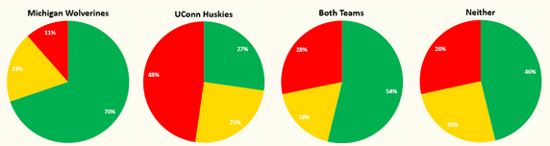
When comparing the sentiments to each team, Figure 8, we found that Michigan received the most positive comments percentagewise, whereas Arizona received the most neutral and negative comments percentagewise.
Figure 8 - Sentiment Including “Both Teams” Comments [Michigan vs Arizona]
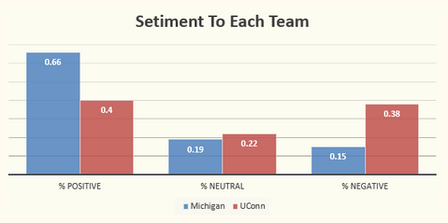
Across both semifinals, the losing teams received more negative comments than positive comments, while the winning teams received more positive comments than negative comments. The winning teams also received about three times as many total comments as the losing teams. In the finals, both the winning team and the losing team received more positive comments than negative comments, but the losing team still had a lot of negative comments attributed to them. Following the same trend, the winning team again received about three times as many comments as the losing team.
This leads us to two findings. First, we observed that the winning team is more likely to receive comments than the losing team. Secondly, the winning team is more likely to receive positively attributed comments than negative comments.

4.2 Sentiment Trajectories: Michigan and UConn
Because Michigan and UConn advanced to the championship, they each appeared in the most recap videos on the March Madness YouTube channel. Their sentiment trajectories across all games played were tracked to examine how fan reception evolved throughout the tournament.
Figure 9 - Michigan’s Sentiment Across the Tournament
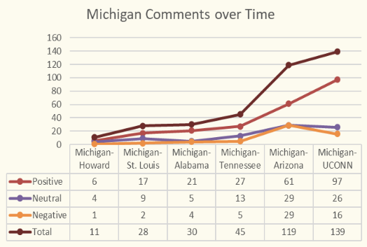
Figure 10 - Conn’s Sentiment Across the Tournament
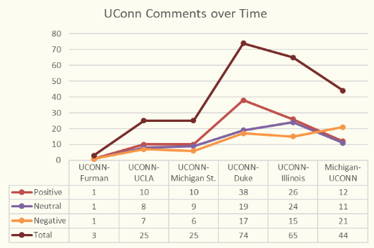
When looking at Michigan, we found that as they advanced in the tournament, their total number of comments continued to increase. Along with this, their total amount of positive comments also continued to increase across the entire tournament, taking up most comments in every game. When comparing neutral and negative comment counts, Michigan never received more negative comments than neutral comments, only ever tying for the Michigan vs Arizona Game.

When looking at UConn, we found that as they advanced in the tournament, their total amount of comments also continued to increase, but fell off starting at the UConn vs Illinois game. We also found that the total amount of positive comments followed the same trend as Michigan until the final, where UConn lost, receiving more negative comments than any other comment attribution. UConn never received more neutral comments than positive comments, only tying in the first game played.
When comparing both outcomes, we found that as teams progress through the tournament, sentiment trended more positively until a team lost. Once UConn lost, the sentiment flipped negatively.

4.3 Sentiment by Seed Number
Finally, we looked at how well-received each team was based on their seed number. For these calculations, only comments that were made out to be specifically about one team were counted. The reason behind this was to ensure that the comments and the seed number matched. The results for the top 8 and bottom 8 seeds can be seen below in Figures 11 and 12, respectively.
Figure 11 - Sentiments Attributed to the Top 8 Seeds
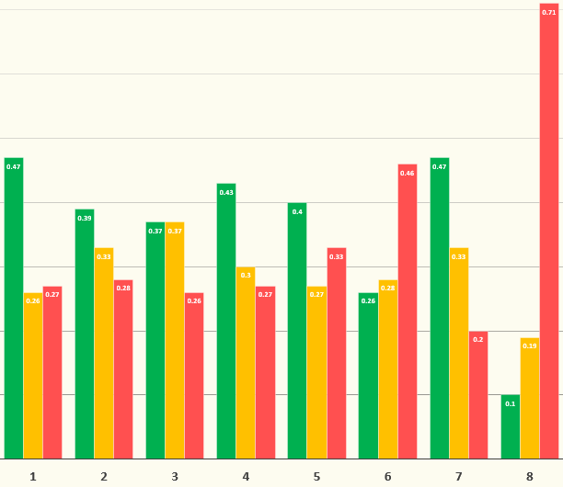
When comparing the top 8 seeds, most seeds were received more positively than negatively, with the outliers being the 6th and 8th-seeded teams. When taking a closer look at the 8 seeds, most of the negative percentage is attributed to the St. Louis-Georgia game, where Georgia lost and received 34 negative comments. Comparatively, the combined negative comments to the rest of the 8 seeds totaled only seven. Another thing to note is that the positivity towards the 1 seeds comes mostly from Michigan, as they went farthest and won the tournament. Removing them from the total leads to the 1 seeds receiving predominantly negative comments with 37%. The most positively received teams in the top 8 seeds were the 1 and 7 seeds at 47%.
Figure 12 - Sentiments Attributed to the Bottom 8 Teams
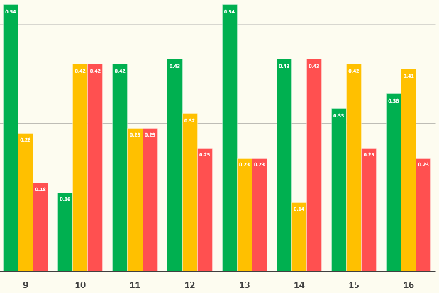
When comparing the bottom 8 seeds, most seeds were again received more positively than negatively, with the outlier being the 10 seeds with a 42% negative rating. The most positively received teams in the bottom 8 seeds were the 9 and 13 seeds at 54%. When looking closer at the 9 seeds, the majority of the positive percentage is attributed to the Iowa Hawkeyes, with a total of 58 positive comments. Comparatively, the combined positive comments to the rest of the 9 seeds were totaled at only 37.
When comparing the top 8 seeds with the bottom 8 seeds, we found that the top 8 received the most comments, with a total of 1940. The bottom 8 seeds only received 443 comments. When looking at the combined percentages in Figure 13 below, we found that both seed groups received a majority of positive comments, with the top 8 receiving 40% and the bottom 8 receiving 46%. When looking at the negative percentages, we found that the top 8 seeds received 7% more comments than the bottom 8 seeds.
Figure 13 - Comparison between The Top 8 and Bottom 8 Seeds
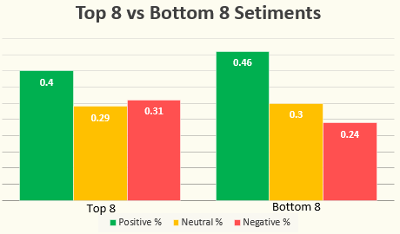
Overall, the bottom 8 seeds were received more positively, percentagewise, than the top 8 seeds. The top 8 seeds also held the two most negatively received seeds (6 and 8), whereas the bottom 8 seeds held the two most positively received seeds (9 and 13).

5. Discussion and Limitations
The NCAA March Madness Tournament has 63 games every year, which limits the project in multiple ways. The scalability of the project is limited by the difficulty of retrieving the video URLs, requiring manual copying for every video. Additionally, since the bracket is single-elimination, half of the teams are eliminated after a single game, which drastically skews the availability of data for each team. Compounding that effect is the fact that teams with more raw data usually have more positive data, skewing the overall data distribution, since they won most of the games they played.
The method of comment collection also had some limitations, primarily likes and replies, as well as the difficulty in proving the accuracy of the collected results. While the YouTube API allows for the collection of like counts and replies, their inclusion would have convoluted the data and was ultimately excluded. In an ideal world, the likes would have been included to provide magnitude amplification to the sentiment expressed in any given comment, and replies would have been included to increase the size of the data pool, but that was outside the scope of the project. Lastly, while the results present in the data are logical, the scope of the number of comments across as many games limits the ability to properly fact-check the results for accuracy, so there is always the possibility that the model is not as accurate as assumed, which would sully the findings.

6. Conclusion and Future Work
The project is easily expandable in several directions. The first possibility is expanding the analysis to encompass the Women’s tournament as well. This would allow for comparisons across not only individual teams or schools, but also gender. The second possibility is to expand the project back in time, pulling comments from previous years and allowing for longer tracking as well as more data for each team and seed across tournaments. This would reduce the potential skewing of seed results based on unfavorable teams occupying those seeds or unusually poor performance for the year. Additionally, some fine-tuning could polish the already retrieved results. Training the RoBERTa model on more modern slang and basketball terminology would allow for better classification of the sentiment for each comment. Expanding the dictionary to include each team’s full roster and better capturing of inside terminology or nicknames, or fragmenting comments further to attribute the parts of the comment to the proper sentiment to each team mentioned, could further elucidate the results.

7. Sources
March Madness. March Madness, YouTube, www.youtube.com/channel/UCKjEtnnXEHsXE9IvCb92V7g. Accessed 15 May 2026.
Loureiro, Daniel, et al. Twitter-RoBERTa-base for Sentiment Analysis – UPDATED (2022). Cardiff NLP, Hugging Face, 2022, huggingface.co/cardiffnlp/twitter-roberta-base-sentiment-latest. Accessed 15 May 2026.
Claude AI was used to assist in formatting this report.

